NFL Picks Weekly Logs

Team members: Sean Monahan, Lou Dignam, Colin Deckert

Log 1:

* Design a front page skeleton (Colin)
* Create a simulation that will be used to test our software (Sean)
* Create an initial database schema (Lou)
* Initialize the git repository (Lou)

Log 2:

* Continue work on the front page and research how to implement sports news feeds from ESPN, Yahoo, NFL.com, etc. (Colin)
* Modified the database design to make it more efficient and straightforward (Sean and Lou)
* Continued to work on simulation to take teams’ offensive rating into account (Sean)

Log 3:

* Researched possible APIs we could use to retrieve NFL statistics (Colin)
* Created the database from the modified schema (Lou)
* Synced the simulation with the newly modified database (Sean)

Log 4:

* Received an API key from Sportsradar.us (Colin)
* Began populating the database with team and schedule data (Sean and Lou)

Log 5:

* Finished populating the database with the NFL schedule (Sean and Lou)
* Studied Bootstrap and continued work on homepage (Colin)
* Completed user registration and login (Sean)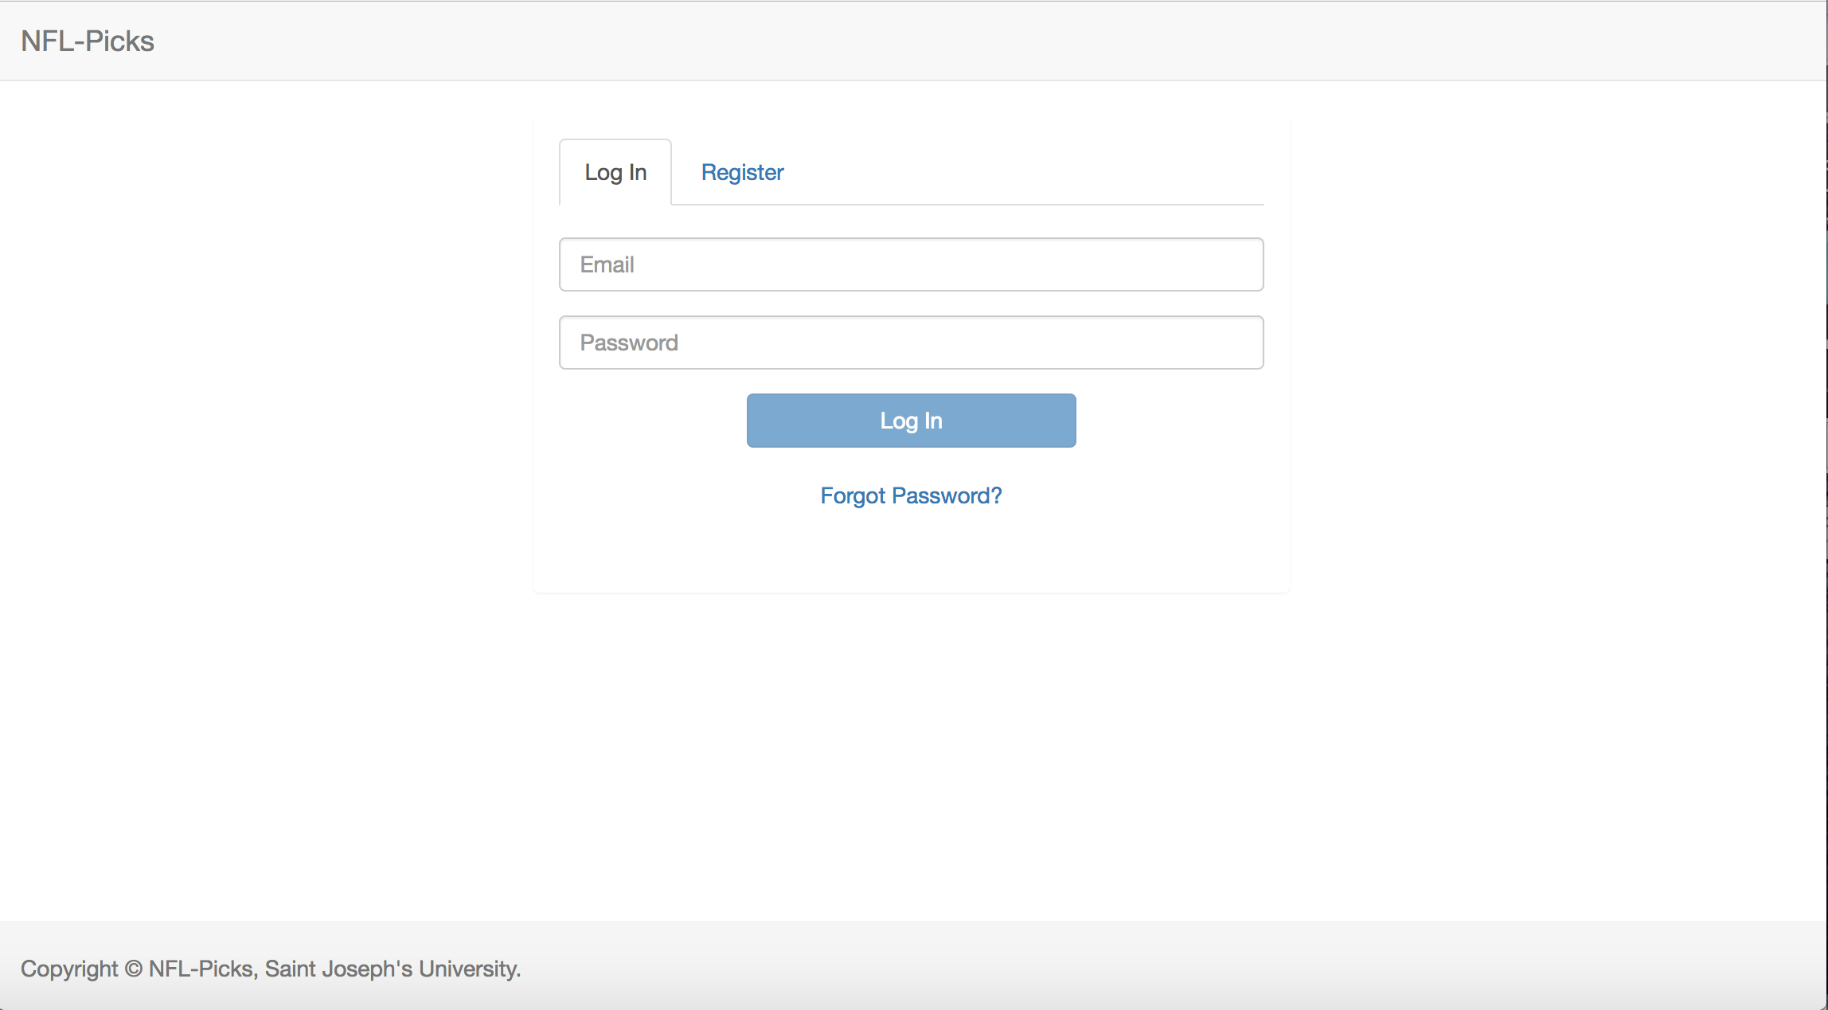

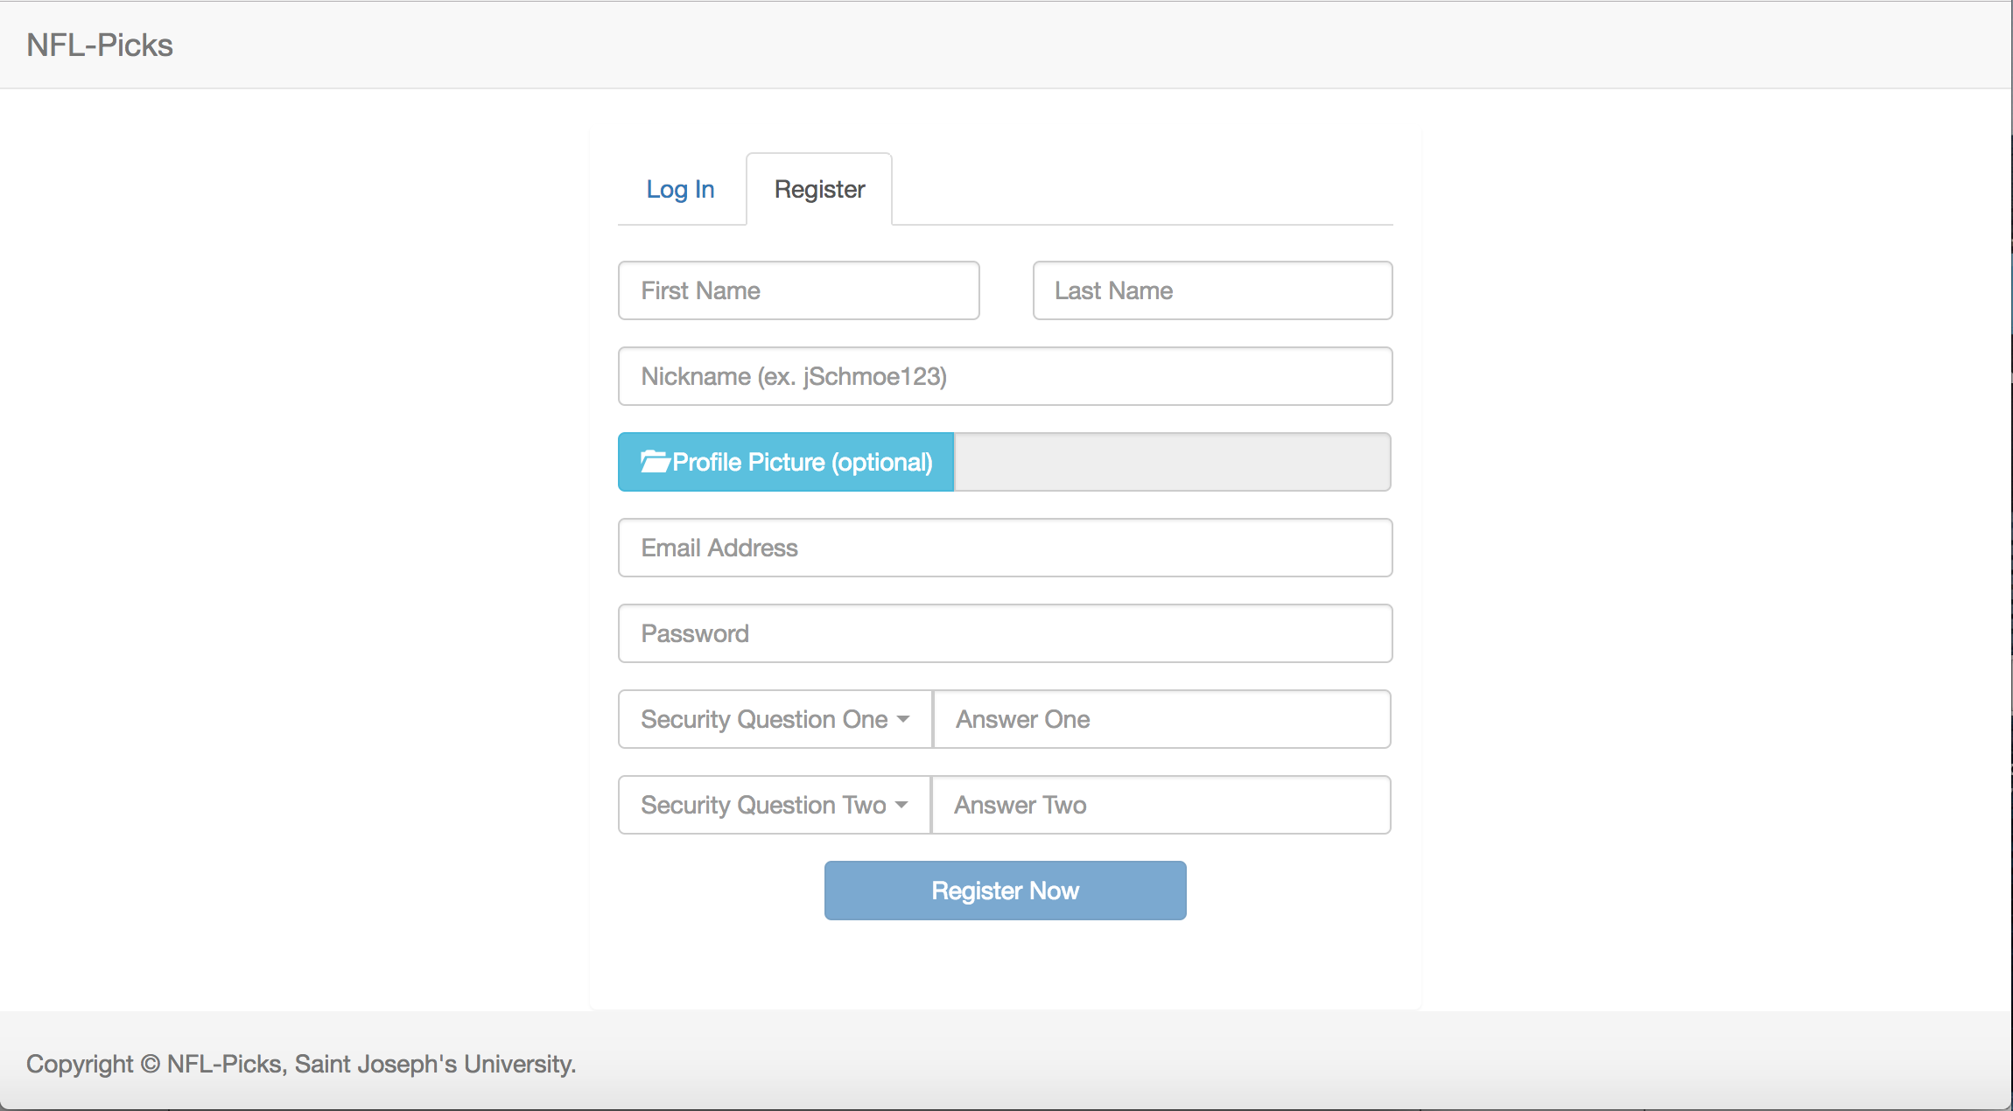

* Cleaned up header and footer (Sean)

Log 6:

* Finished work on pool creation and the pool manager is now able to invite members to join his or her pool (Sean)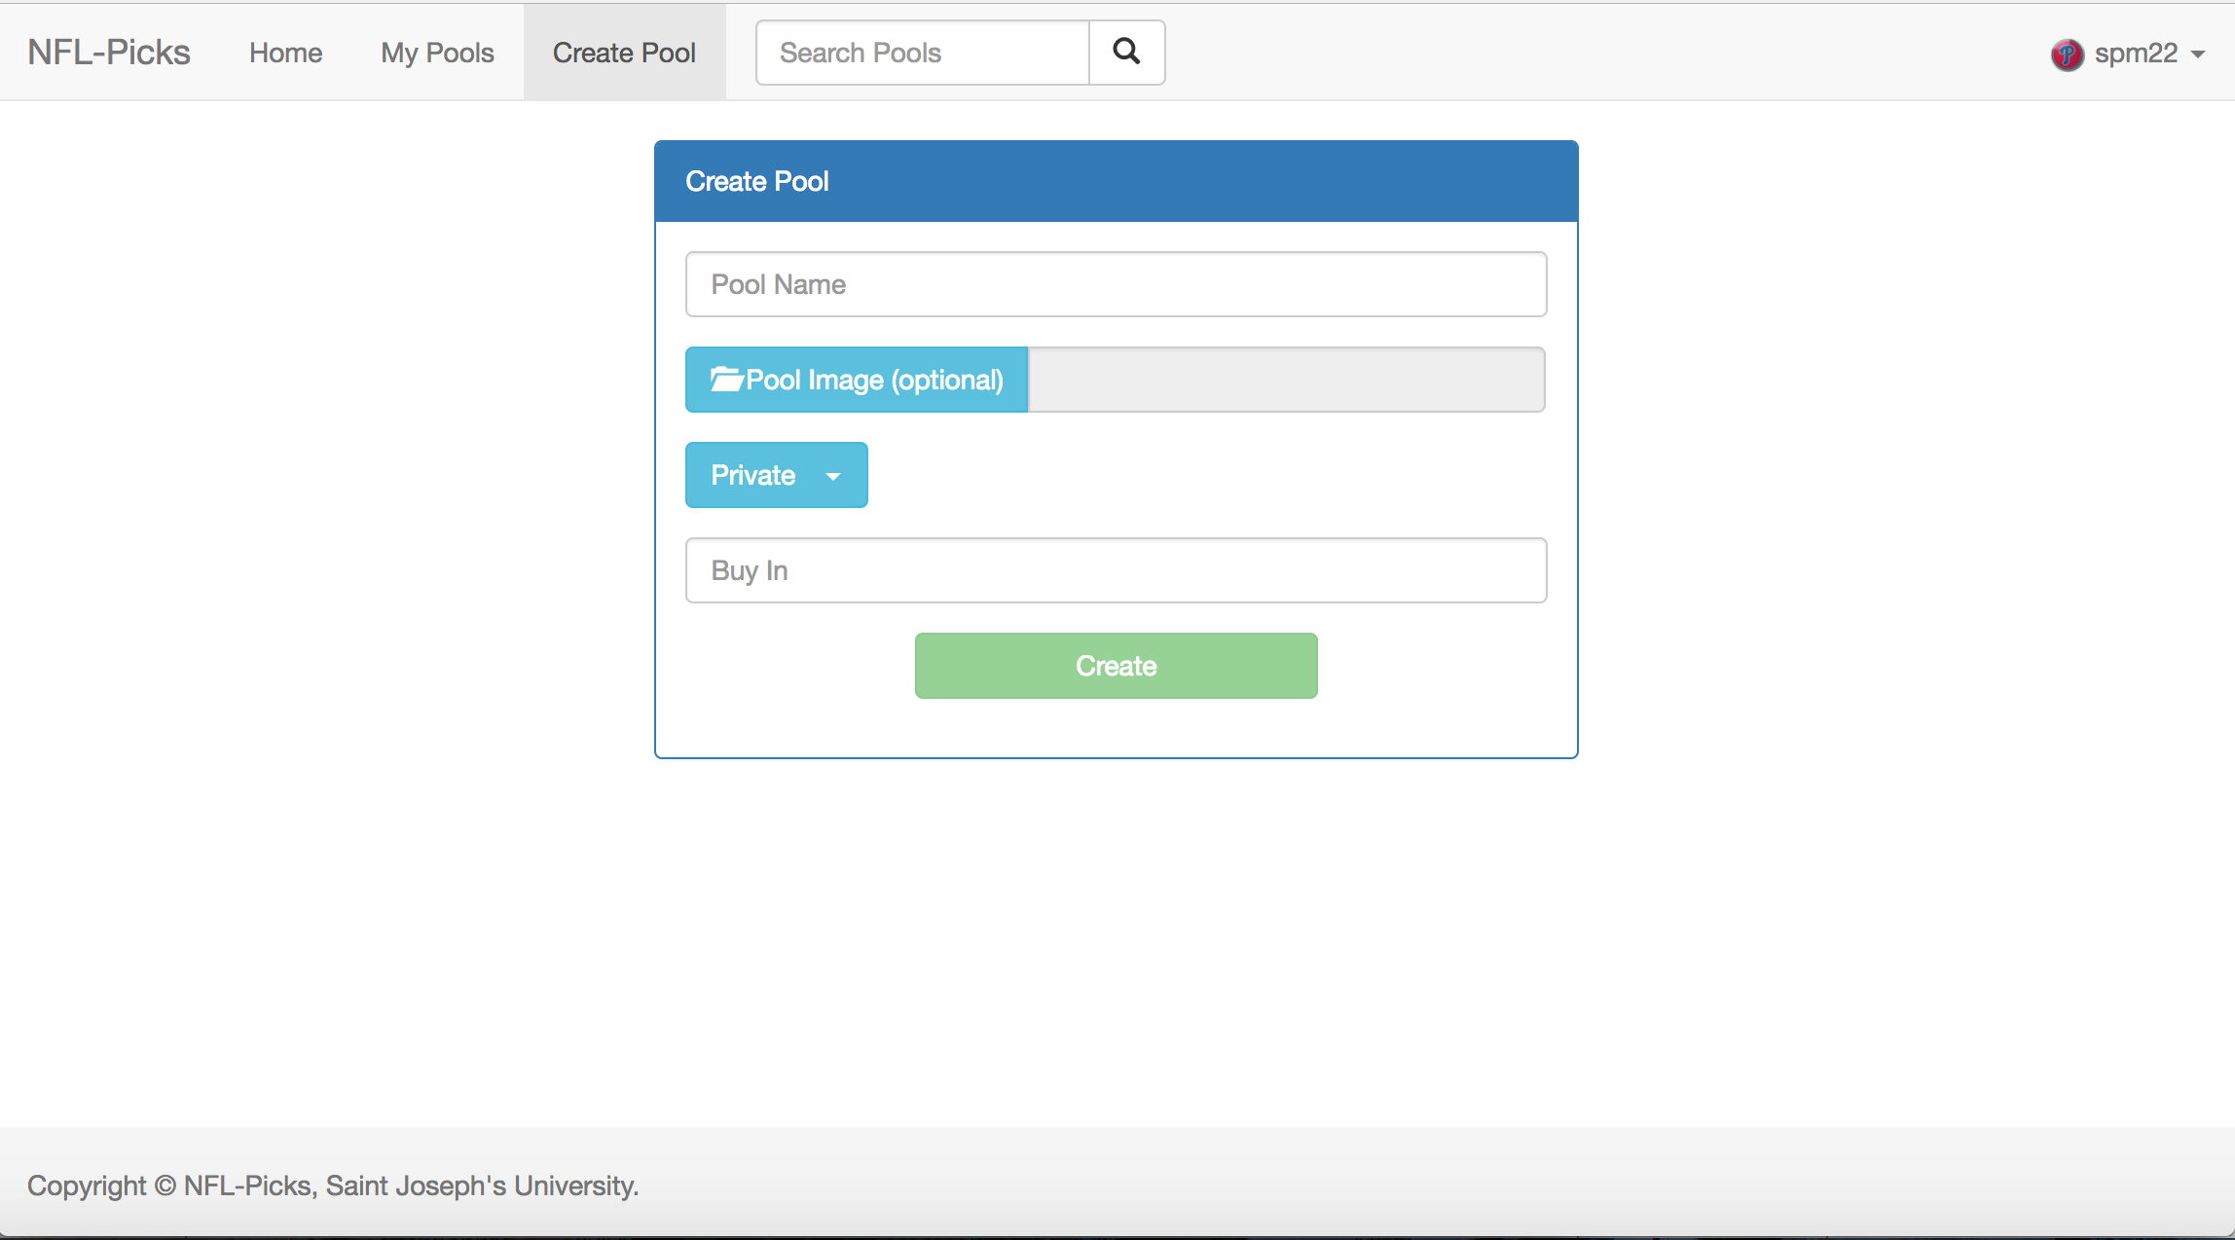

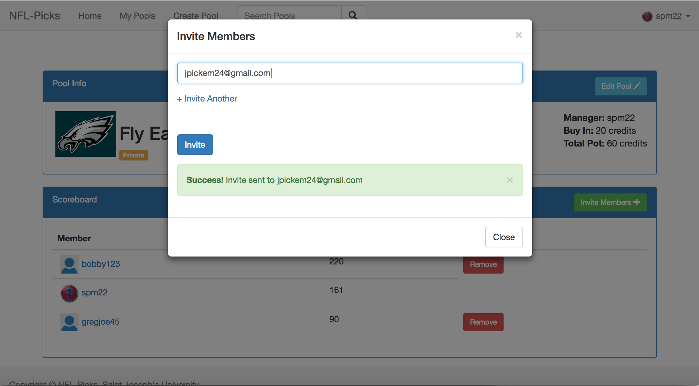

* A user can either accept or decline an invitation, if accepted the user will become a member of the pool (Sean)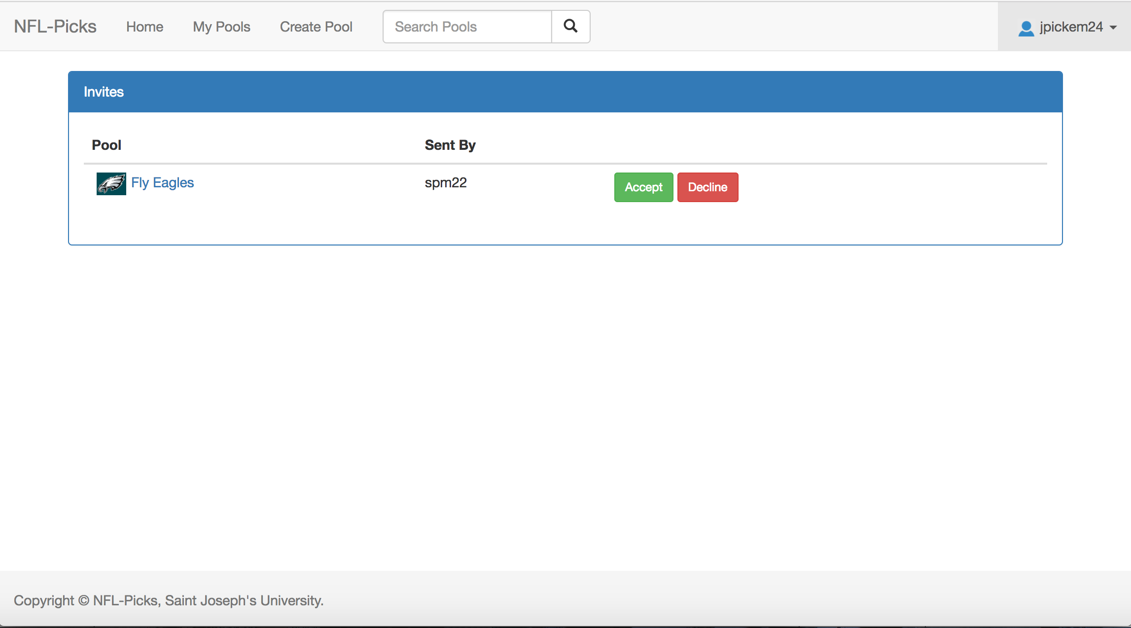
* Some UI cleanup (Sean)
* Created a profile page where the user can see their information and update it if necessary (Lou)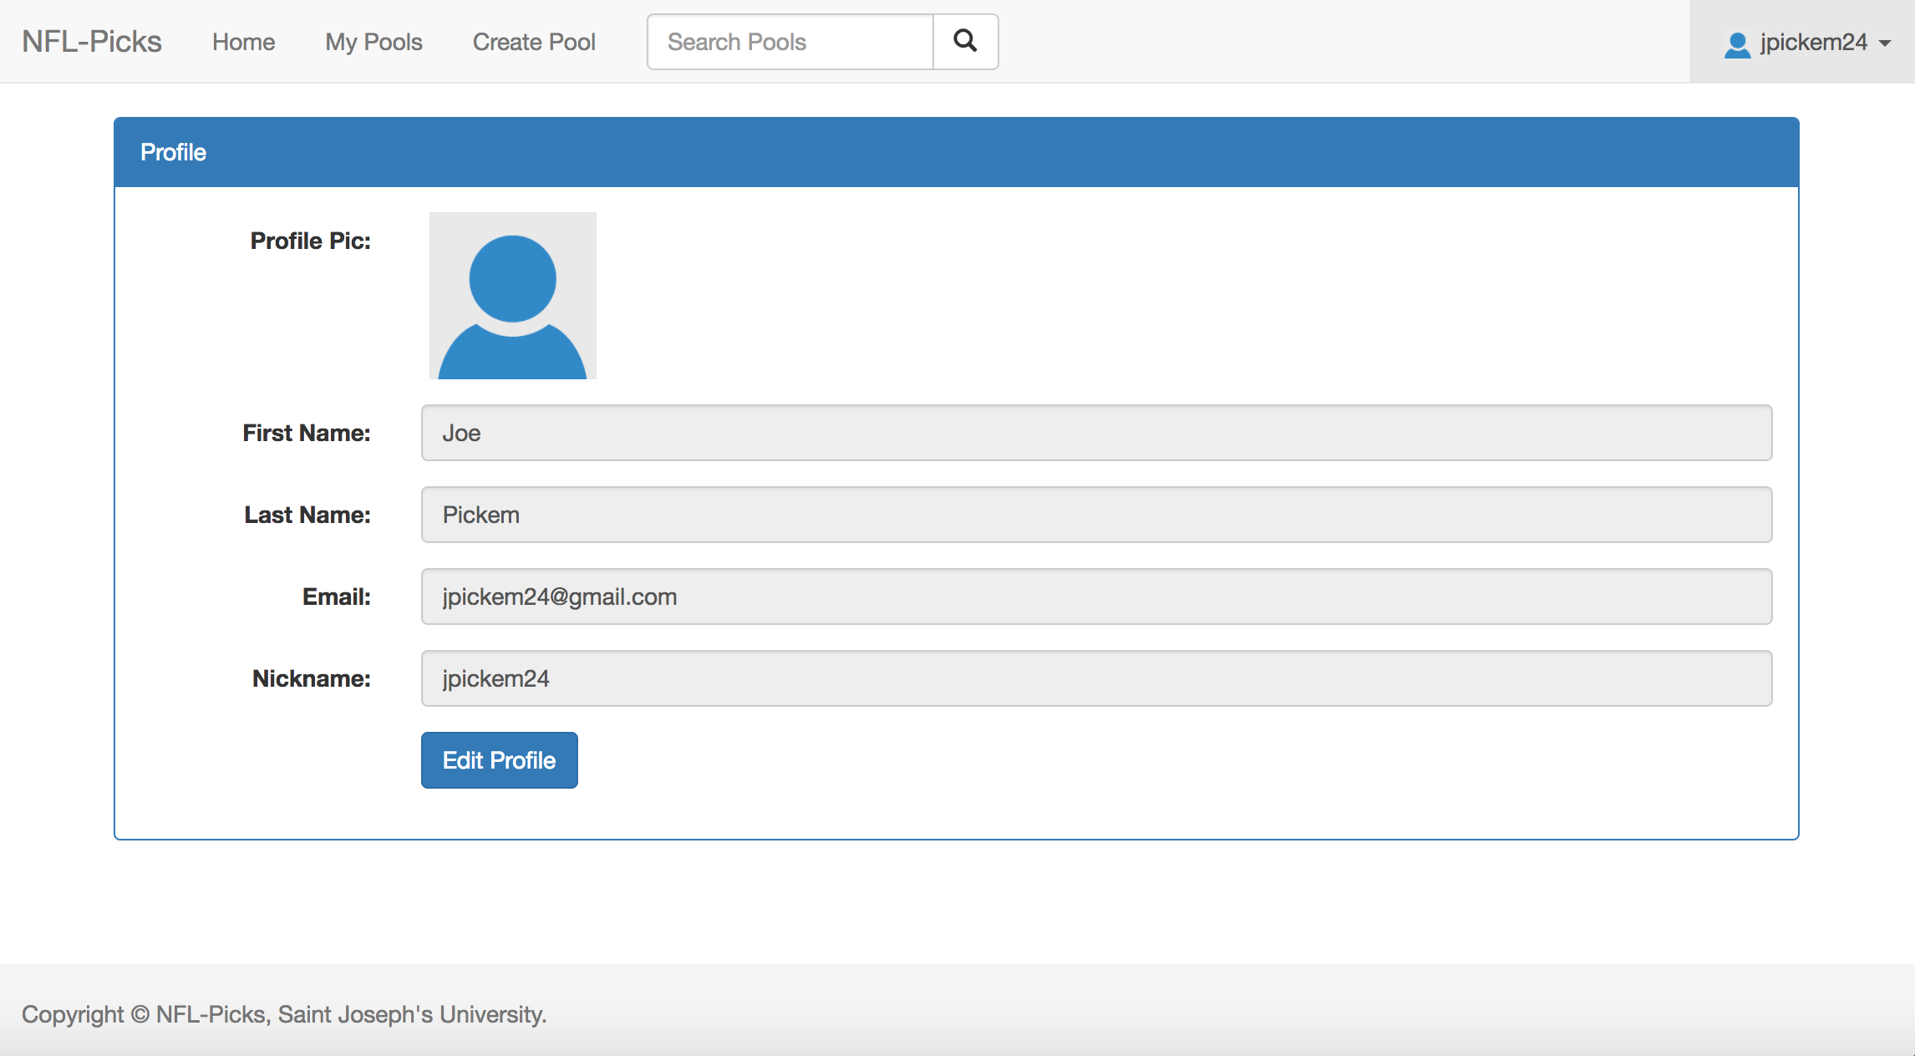
* Continued to learn bootstrap and work on the home page (Colin)

Log 7:

* Began work on page where user can make their picks and view past picks (Sean)
* Updated the Simulation to assign points to user if their pick for that week was correct (Sean)
* Fixed bug where user could join pool even if they did not have enough credits to pay the buy in (Sean)
* Began work on a page to display the past picks of a certain member of the pool (Lou)
* Tested the site to see if any bugs were present (Lou)
* Continued to work on the homepage (Colin)
* Began populating the database with team logos (Colin)

Log 8:

* Finished implementing functionality of making and saving picks for each week (Sean)
* Fixed some layout issues (Sean)
* Updated layout on page that displays information about the pool (Sean)
* Continued work on the page to display the past picks of a certain member of the pool (Lou)
* Discovered some layout issues and helped to correct them (Colin)
* Continued work on the home page (Colin)

Log 9:

* Manager can now update pool info (Sean)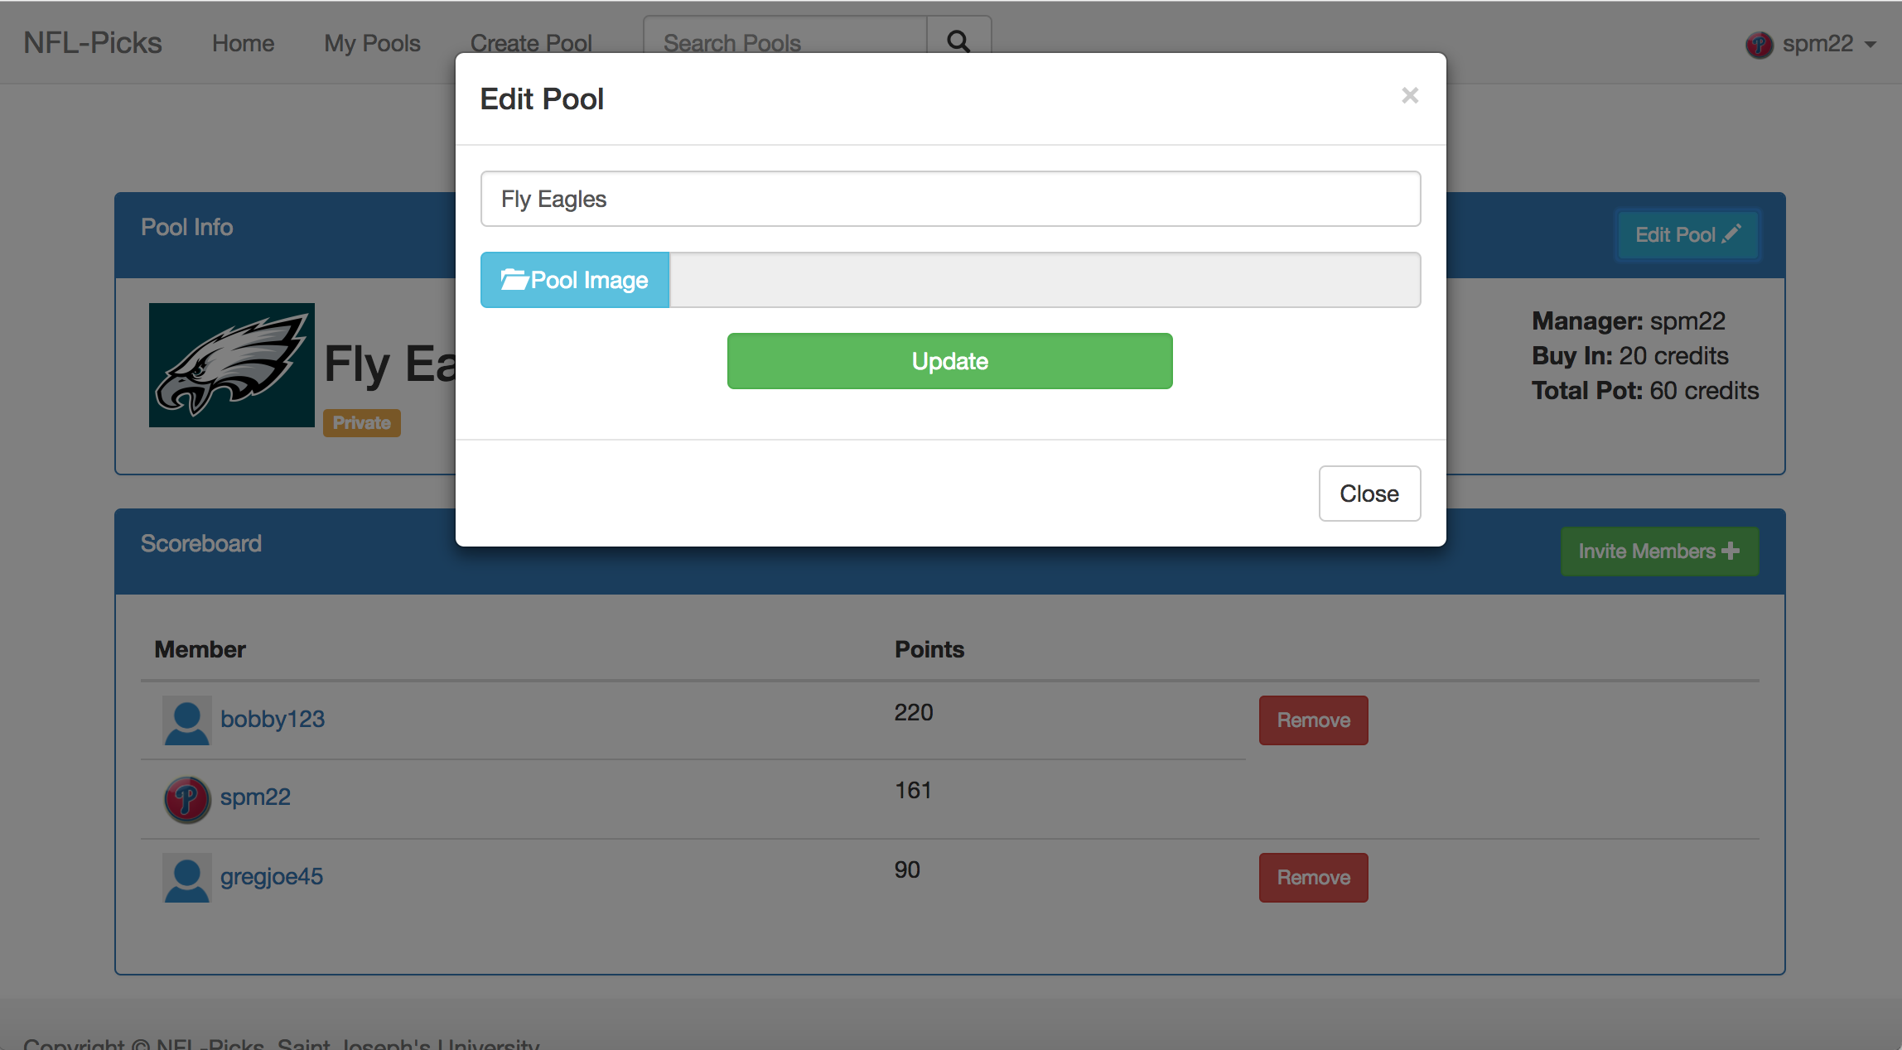
* Member of pool can now leave the pool (Sean)
* Implemented a default image for profile picture and pool picture so that both can be optional (Sean)
* Populated database with NFL team logos (Lou)
* Added team logos to my_picks page (Sean)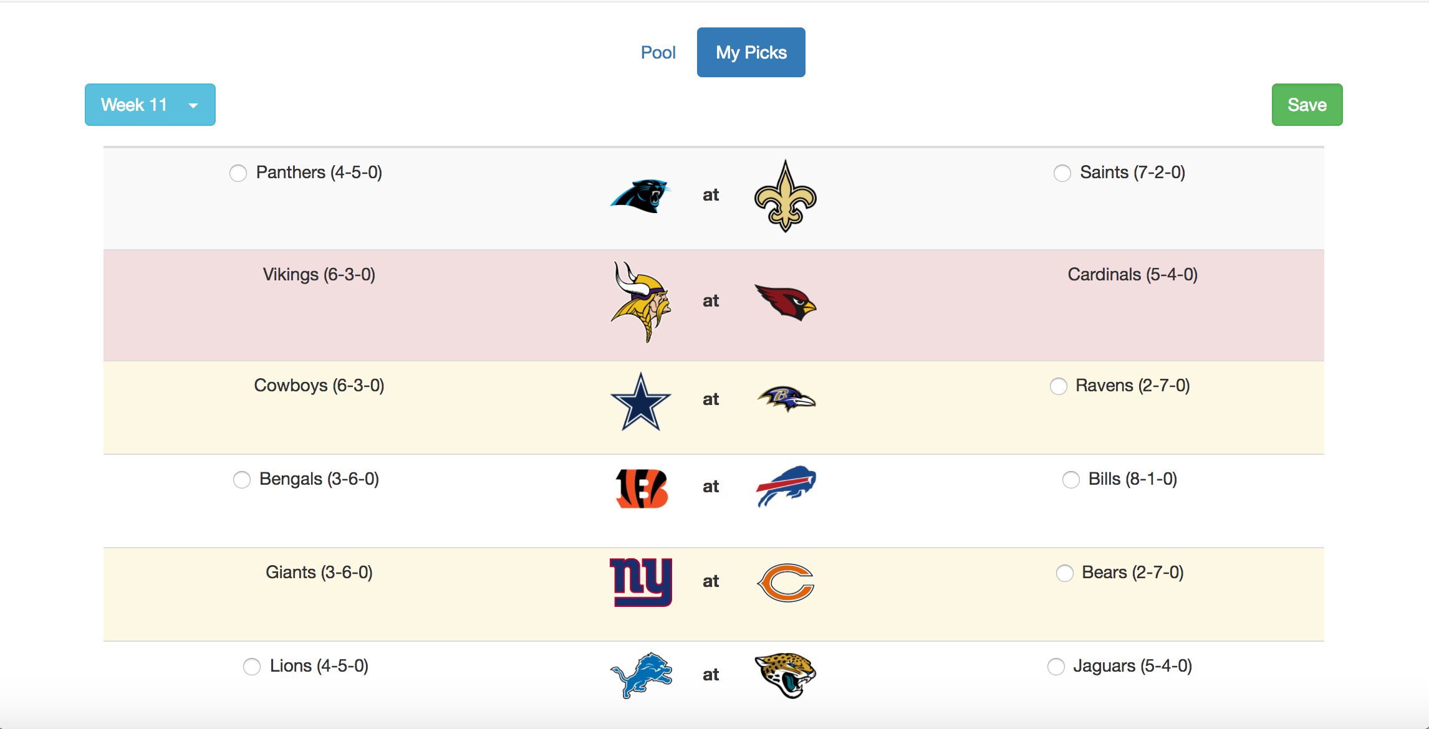
* Continued work on the page to display the past picks of a certain member of the pool (Lou)
* Continued work on the homepage (Colin)
* Looked into password encryption (Colin)

Log 10:

* Public pools can now be created (Sean)
* Began work on implementing a way for users to search for public pools to join (Sean)
* Reorganized the navigation bar and performed some minor bug fixes (Sean)
* Completed the page that displays the past picks of a certain member of the pool (Lou)
* Looked into a fix for the picture orientation bug (Lou)
* Continued work on the homepage (Colin)
* Continued looking into password encryption (Colin)

Log 11:

* Users can now search for public pools to join (Sean)
* Users can join the public pools from the search page (Sean)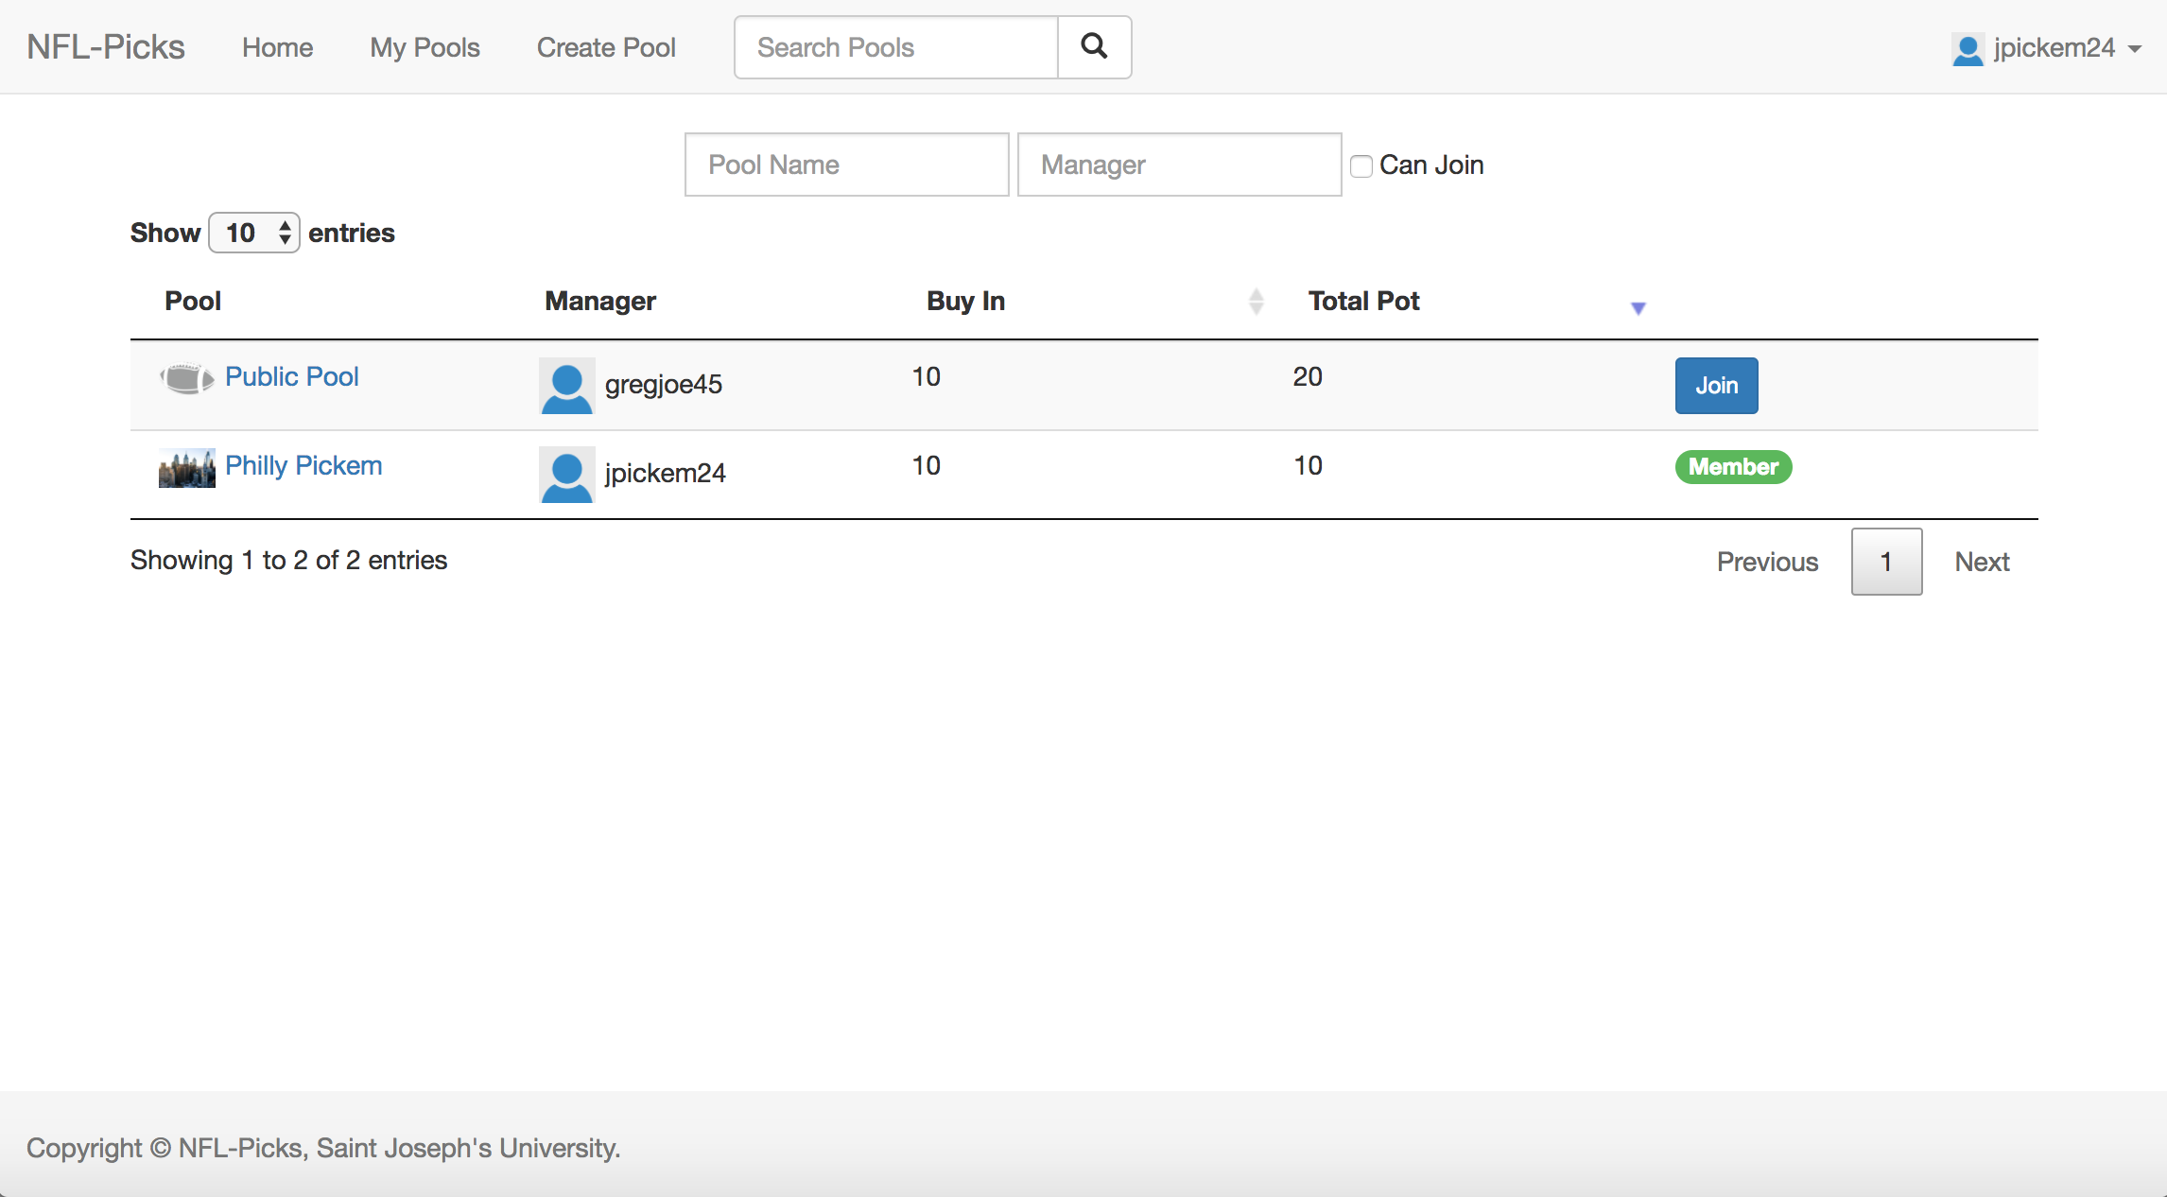
* The manager of a pool can now remove members from the pool (Sean)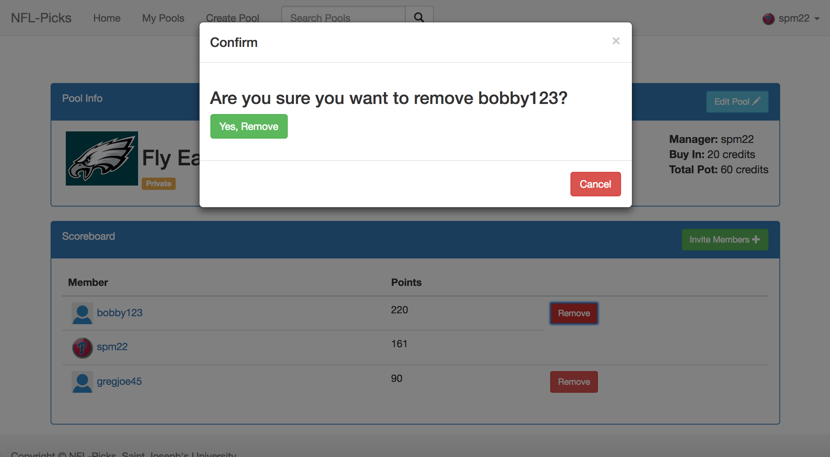
* Some minor bug fixes (Sean)
* Began work on password retrieval through security questions (Lou)
* Continued looking into a fix for the picture orientation bug (Lou)
* Continued work on the homepage (Colin)
* Continued looking into password encryption (Colin)

Log 12:

* Updating of simulation for current version our website (Sean)
* Worked on end of season division of pot for winners (Sean)
* Updated DB to work with new simulation (Sean)
* Twitter feed is now on the home page (Colin)
* Continued to investigate password encryption and credit card implementation (Colin)
* Finished security questions for registration page (Lou)
* Continued to work on “Forgot Password” Section of login (Lou)

Future plans:

* Finish updated version of simulation (Sean)
* Finish division of pot for winners of the pool (Sean)
* Finish password retrieval section of login (Lou)
* Continue looking into the picture orientation bug (Lou)
* Continue work on the home page (Colin)
* Include scores and other sport related news on to home page (Colin)
* Continue testing the site (Sean, Lou, Colin)
* Continue thinking about ways to make the site look better (Sean, Lou, Colin)

Log 13:

* Pushed Working Encryption method (Sean)
* Touched up details for Leaderboard (Sean)

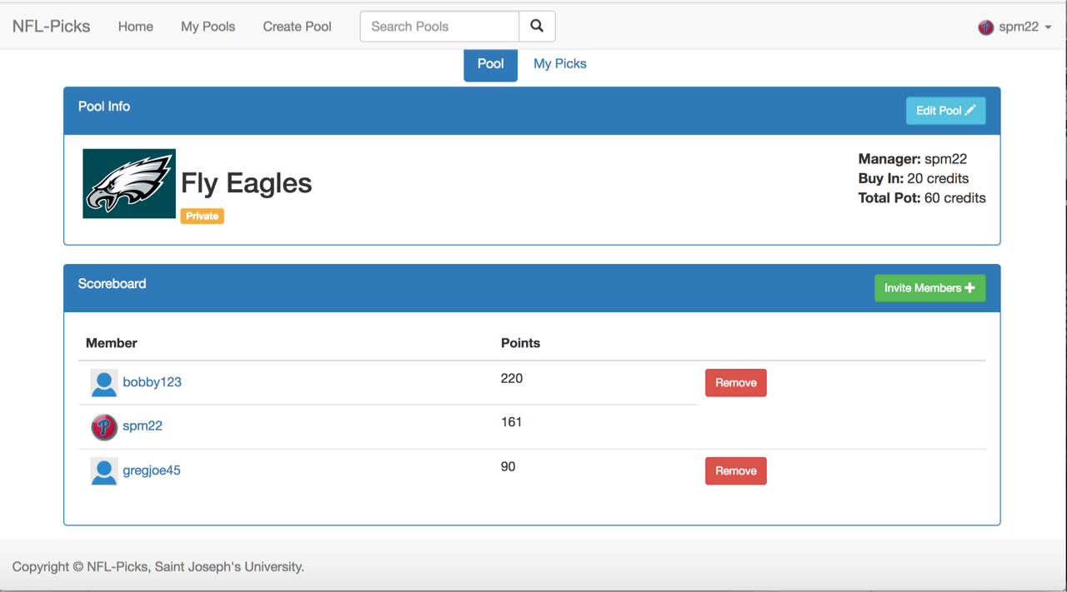

* Complete Forgotten Passwords process (Sean)
* Worked on most recent NFL scores on home page (Lou)
* Stylized most recent NFL scores on home page (Lou)

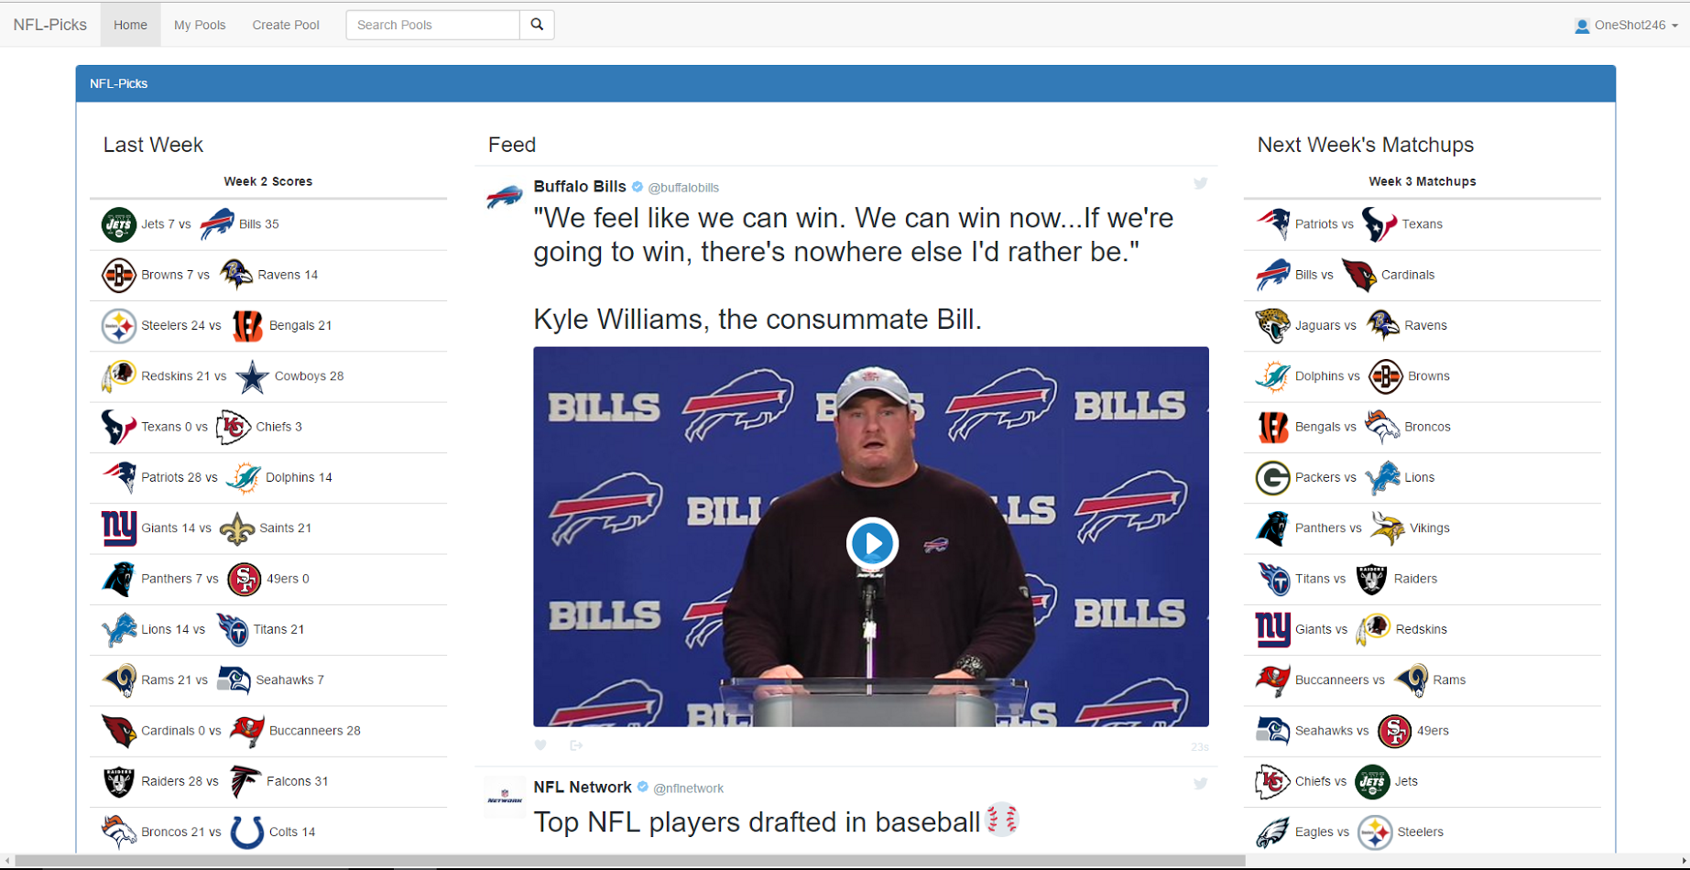

* Worked on next week’s NFL matchups on home page (Colin)
* Stylized next week’s NFL matchups on home page (Colin)

Log 14:

* Added some protection for SQL injection to the login page (Sean)
* Made some finishing touch ups to the appearance of the home page (Sean)

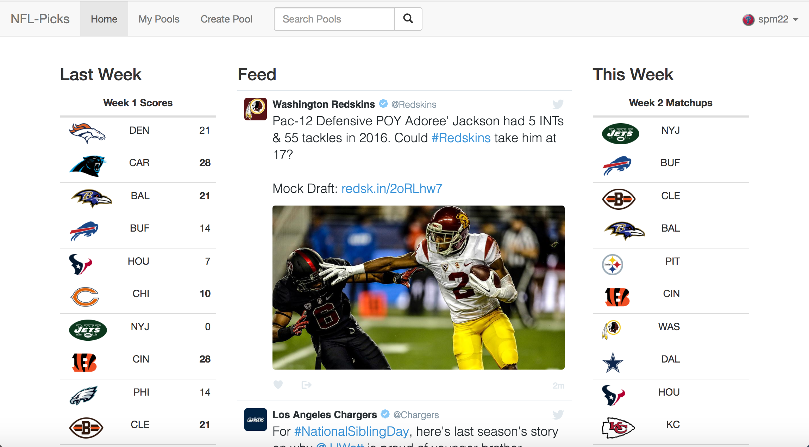

* Continued testing the site (Sean, Lou, Colin)
* Finished work on the poster (Sean, Lou, Colin)
* Started preparing for the poster presentation and the department presentation (Sean, Lou, Colin)

Future plans:

* Continue testing the site (Sean, Lou, Colin)
* Make finishing touches and fix any bugs (Sean, Lou, Colin)
* Prepare for poster presentation and department presentation (Sean, Lou, Colin)